OCTOBER/NOVEMBER 2022
THE GROWLER

Newsletter of the
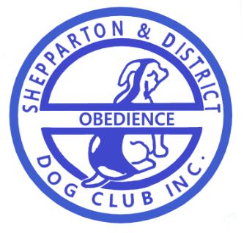
Established 1974

Note: Articles appearing in this Newsletter are considered to be of interest to our readers and do not necessarily express the opinions of the Committee of Editor of the S&DODC Inc. Who accept no responsibility for the accuracy of claims made by the advertisers in this Newsletter.
SHEPPARTON & DISTRICT OBEDIENCE DOG CLUB Inc.
Inc. No. A0017293M
PO Box 6230, SHEPPARTON VIC 3632

LIFE MEMBERS
Derick DEANE | Vern DEARICOTT | Paddy DEANE | Anna HATTON | Cath GRIFFITHS
Barbara STADING | Sue POLKINGHORNE | Val BIRCHELL | Dianne PELL | David BIRCHELL
Merle HOSIE | Malcolm MCLEOD | Marie MCLELLEN | Olive BARKAUKAS | Marg DELAI
Paul GEESON | Fred MURLEY | Kath MURLEY | Les BESWICK | Elva BESWICK
Julie RAFFERTY | Iola IBRHAIM | Chris THOMSON | Sharon ALLEN | Sharon VAN BUUREN
Darryl WALKER | Leigh WILLIAMS | Helen VERNON | Paul O’Brien

OFFICE BEARERS AND COMMITTEE 2021/2022
President: Leigh Williams 0419 315 991 (no private numbers, no calls after 8pm please)
Vice President: Helen Vernon
Secretary: Barb Lloyd
Assistant Secretary: Julie Rafferty
Treasurer: Vacant (Leigh Williams Acting Treasurer)
Committee: Marg Delai, Mellissa Moore, Helen Vernon, Tracey Simmons, David Sanford, Paula Laidlaw
Trial Manager: TBA Trial Secretary: Julie Rafferty
Property Steward: TBA Editor: Alicia Jones

Class Times
Beginners/Newcomers and Novice and above Classes: 9.00am to 9.45am
Intermediate and CCD Classes: 10.00am to 10.45am
Every Sunday – Beginner Class: 9.00am – 9.45am
1st Sunday: 9.00 am Obedience for Beginners and Novice
2nd Sunday Obedience 10.00 am to 10.45 am, Committee meeting 11am
3rd Sunday Obedience 10.00 am to 10.45 am, Agility/Rally-O 10.45am to 11.45am
4th Sunday Obedience 10.00 am to 10.45am, Every second month on the last Sunday; Graduation testing only 9.00am

Heat Rule
When the weather forecast for Sunday by the BOM for Shepparton is 36 deg, or above as declared on the prior Saturday night, there will be no training on Sunday morning even if the weather forecast is revised.

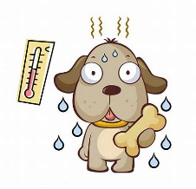
Presidents Page –
We almost made it through this year without the need to cancel training, this time it was not heat policy or Covid but floods that forced us to cancel. With the decision made and posted on Facebook to let everyone know, on the Sunday morning I headed down to the club rooms just in case anyone came along, coming down Balaclava Road before Packham St in front of the Primary school was a road closed sign and a large section of the road that was under water, this was confirmation that we had made the right call to cancel training. I managed to go down back streets without driving through water or road closed signs to find a small amount of water in the gutter at our driveway that was flowing down the street, a sign of things to come. The water slowly rose all day Sunday and peaked on Sunday night. We were able to find a drone video of the club house at the peak of the flood that showed water all around the building and the grounds, the good news is it was very shallow and a very long way off our floor height (where we had moved all the items from the shed floor). There had been a small amount of water in the shed, a bit of a pressure wash (mud was rather sticky and just a hose did not do it) and we were as good as before. The same can not be said for our grounds that were very wet, after a second week off we returned to the carpark as the grass was sodden and full of mosquitos. A big thank you must go to Helen’s partner Peter for spending a day and a half at the club pumping the water off the grounds, without this we may have been still facing very wet grounds (At least worse than we have had with the persistent rain).
We have been very lucky to very minimal impact from a major flooding event and our thoughts are with all the residents and businesses that have been impacted and are undertaking a major recovery effort.
It is hard to believe that we are already at the end of our training year and our annual Christmas party due on the first Sunday of December, it has been a fantastic year with lots of new puppies learning the ropes and seeing them progress and develop their skills over the weeks and months is very exciting and rewarding for owners and instructors alike. Equally it has been great to hear the results of members that have been out competing in their chosen sports at a high standard and doing so well, the table has often been adorned with the ribbons and prizes that have been gained.
I would like to take this opportunity to thank the committee, our wonderful instructors and those members that step up and help when needed, a volunteer club does not work without you and everyone’s efforts do not go without being noticed.
I look forward to seeing everyone for our end of year break up for breakfast, some games, and awards to finish the year off. I cannot wait to see what fancy dress costumes we get this year! Our summer break may seem like a long time, but with the busy lead up to Christmas, the holiday period, and no doubt a few hot days in January we will be back at the start of February before you know it. This is an important time to let everyone have a break, including our dogs, you would be surprised what a bit of a rest from training and seeing all their friends can do, they will come back with fresh excitement and be keen to get back into it.
Enjoy your holidays and have a safe and happy Christmas and New Year and we look forward to seeing you all again at the start of February.
Kind Regards,
Leigh Williams
President

WELCOME TO THE FOLLOWING NEW MEMBERS

Please remember to wear your name badge each week. This is the only way instructors get to know your name as they have no problem recognising your dog.

Member: | Dogs Name: | Breed of Dog
Amanda Heard and Andrew Saint | Lucy | border collie
EthanCulpan | Leo | Lab
Robyn Melbourne | Ruby | Husky x poodle
Connie Mangiameli | Rafael
Sebastian Mangiameli | Rafael | Labrador
Denis Keen | Norm | Cocker spaniel
Andrew Taylor | Daisy | heeler
Kayla Rustem | Ollie | Labrador
Olivia Marshall | Harlo | Cavoodle
Ingriot and Glenn Withers | Jack | Kelpie
Gillian Ryhorchuk | Podge/Cassy | Dingo
Sophie Gallace | Henry | Kelpie
Jaine and Karlein Burn | Maisie | Kelpie
Ilse VanLipzig | Harley | Red Heeler
Katelyn Gillespie | Dozer | Labrador
Hailey Moffatt | Bean | Rottie X kelpie
Jerome Lawson | Patch and Tan | Kelpie X heeler
Taken to soon…..
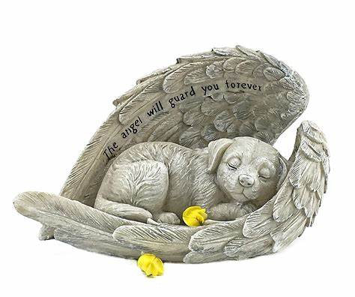
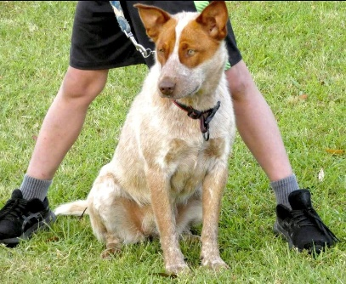
Condolences to our new members the Vanlipzig family on the loss of their much loved Harley just recently.
Harley started as any other, distracted by the world full of life and a strong puller on leash. I had been so pleased to watch her settle into begginers and her owners working in tandom and pulling it all together no words again just hug your dogs tonight…

MEMBERSHIP
With effect from 2020, the membership year runs from 1st January to 31st December each year.

Membership Fees are due for Renewal until the end of February 2022.

If you fail to renew before February 2022, you will be required to pay the joining fee again.

Membership fees have changed for the first time since 2011:
Junior $20.00
Singles $30.00
Family $60.00
The joining fee is $10. Class fees have not changed and remain at $3.00
Here when you need us
7 days per week
2 Wanganui Road, Shepparton
03 5821 3188
7966 Goulburn Valley Hwy, Kialla
03 5823 1202
Your pet is a very important member of your family, which is why we set the highest of standards for our hospital and clinics. We are passionate about doing the very best for your pet, and believe in working together, in alignment with our shared values. We are dedicated to delivering the best veterinary care and expertise at our 2 great locations.

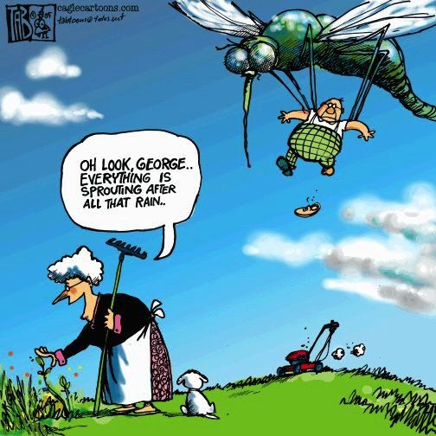
Mosquitos and your pooch
The types of diseases that mosquitoes can transfer to dogs include parasitic infestations, viral infections, and bacterial infections. Mosquitoes itch, but they have much worse effects. Less common is West Nile virus and encephalitis. These diseases are rare in Australia, but heartworm is not. Mosquitoes carry the heartworm parasite, which is common — and very serious. Heartworms are parasites that live in the heart and blood vessels of dogs. Once they have multiplied, they can block the flow of blood to essential organs and disrupt heart function. Whilst this isn’t a common occurrence in Victoria there have been 10 reported cases over the last few years and with the influx in mozzie population with the flood water and current climate prevention and protection is key!
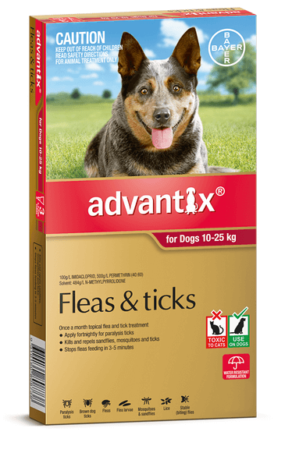
Without going into to much detail some over the counter products for mosquitos
ADVANTIX a once a month spot on for dogs
that also protect against fleas tick flies and mosquitos,

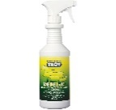
REPELEX a spray for dogs pigs cows and
horses upto twice a day spray that can also be A more natural aproach like nature
used around their living environment ( beds stalls ect ) botanical rosemary and cedarwood

BEST PRACTICE
Remove all sorces of stagnant water around the property includes ground puddles, pots, buckets even the friendly wheel barrow will hold water. Refresh animal water bowls regularly as mosquitos breed in water sources. Propertysurface sprays keeping in mind your pets health as some chemicals are not good for them.
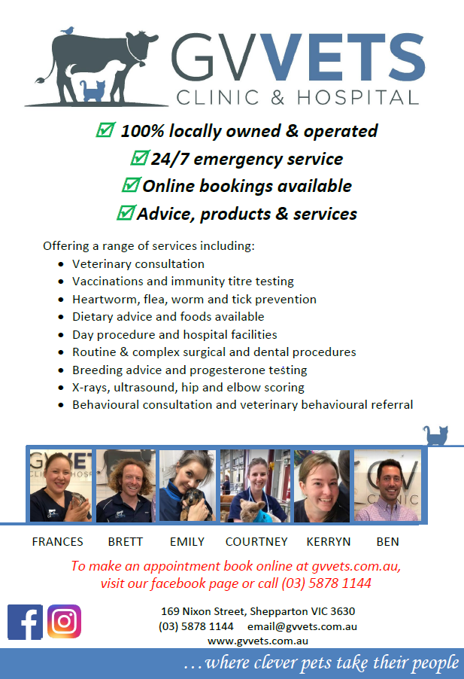

MEET OUR VOLUNTEERS
BARB Lloyd our new secretary no time like the present she is the lady in the know 😉

What is it that keeps you coming back to club? Why do I come to club…. I enjoy doing things with willow and I love helping others enjoy the fantastic relationship that can be formed with their dog and what works for them
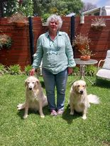
What got you interested in dogs? Always had one growing up, Previous dogs the first dog I ever took to a dog club was a lab x called Sam when I was 18. Fred was next ( lab ) then miss Gypsy, our first Goldie who was actually taken to club by my daughter so then I got Banjo because I figured if I was there for them I might as well have a dog too. Banjo led to the joy of instructing and the excitement ( and frustration ) of trialing and now there is Hugo and finally willow who is just a joy to have around ( especially since she stopped barking ( solved with the help/encouragement of shep club and workshop held by the club))
I competed with banjo, I always said no not for me” but then somehow the bug bit me and we were off and running. We had so much fun traveling around and finding new ways to loose points. We also met some amazing people along the way. Remember help is always around if you are open to new ideas and suggestions. Hugo and I also competed in Rally but it was not his thing so we stopped.

I asked Barb if she were a dog what breed would she be…….. Her response was “ A Goldie of course “ and from the few descriptive word I found I think she wasn’t far off 😊
Golden Retriever · Temperament
Confident, Friendly, Intelligent, Kind, Reliable, Trustworthy

Into the Digital Age

The Club has moved into the digital age with its own website and Facebook page.

The website can be found at www.sheppartonobedience.net and will go through a facelift in the near future.

You will now be able to view copies of the Club’s newsletter, The Growler each month on both the website and Facebook page.

The Facebook page will be the place to go to find out any information about cancelled training or upcoming events.

We also have an email address if any one wish to get in contact with the Club:
sheppartonobedience@gmail.com

HAVE A SAFE AND HAPPY NEW YEAR

Below is instructions on how to make
your own fleece tug toy your dog will love for xmas

XMAS PARTY PRIZE WINNERS
BEST COSTUME 1ST MELLISSA MOORE 2ND BARB LOYD 3RD NICOLE WARDROP
BEST TRICK 1ST KELLIE MCLINDEN 2ND ROBYN MASTERSON 3RD ALICIA JONES
FIDO SAYS EVERYONES A WINNER 😊

To make square braid dog tug toy, you will need:
- Polar fleece or a sturdy alternative material
- Scissors
To weave a basic square tug toy as shown, clean fabric is cut into 4 long narrow strips. You can scale the toy to suit your dog and your materials by altering the width and/or length of the fleece strips. I’ve made many different shapes and sizes over the years. In the toy shown, I worked with approximately 6-8cm x 2m strips. Mine were cut rather uneven. Fortunately, when making a tug with fleece there is no need to be too fussy about straight lines when cutting. Yay! Another thing to love about making fleece tug toys.
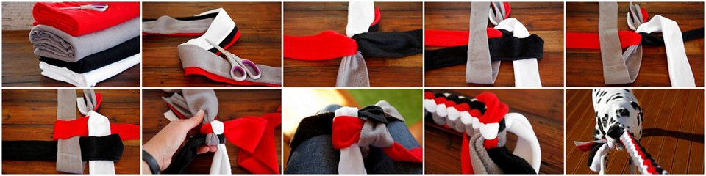

Steps
- Loop and knot one end securely, leaving a “tassel” at the end.
- Weave the fleece using a square knot technique (see diagram below, images above):
  - Spread the strips in a cross (+) shape.
  - Fold the top strip towards the bottom.
  - Fold the bottom strip towards the top.
  - Fold the right strip towards the left, passing over then under.
  - Fold the left strip towards the right, passing over then under.
  - Pull to secure
- Repeat until you are approaching the end. Not too close – see tips below. The top/bottom left/right pattern will cycle naturally from side-to-side with each knot.
- Loop and knot securely, leaving a “tassel” at the end.
- Trim excess fabric if/as needed.
Hot tip ! your dog doesn’t care if its even straight coloured or crooked they will love the stretch and you playing with them. When you get better you can get crafty with changed colour patterns shapes sizes the sky is the limit.
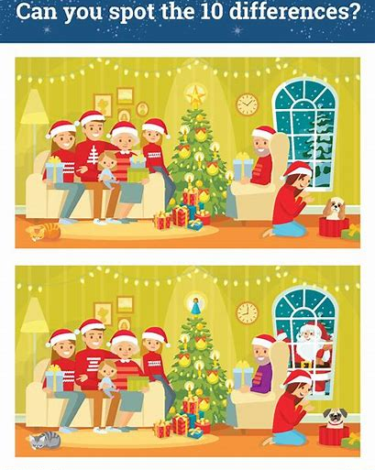
CHRISTMAS CAUTION
This is the last growler for the year 2022. Club is closed over December January returning first Sunday in February.
Excluding nose work and tricks class that will continue to run with a slight change to the schedule and a slightly later start time of 9am club heat rules still apply more details will be posted on Facebook.
So homework is to not stop training and spending quality time with your dogs! It’s a busy time of year but it doesn’t take much to include your dog with guests arriving and travel plans in place work through those skills of polite greetings and general manners, build beautiful memories and experiences for your dogs and keep them safe from foods and decorations that could be detrimental to their health. Stay safe have fun and keep working as a team.
WITH OUR UPCOMING TRICKS TRIAL TO BE HELD APRIL 1ST 2023
I thought it timely to list the skills required to compete, with further information on each skill step by step instructions, how they are scored and all the other rules and regulations available on the ANKC ( Australian national kennel councils ) web page or dogs victoria
https://ankc.org.au/media/9325/20-trick-dog-rules-2020.pdf
each level requires more tricks with increasing difficulty
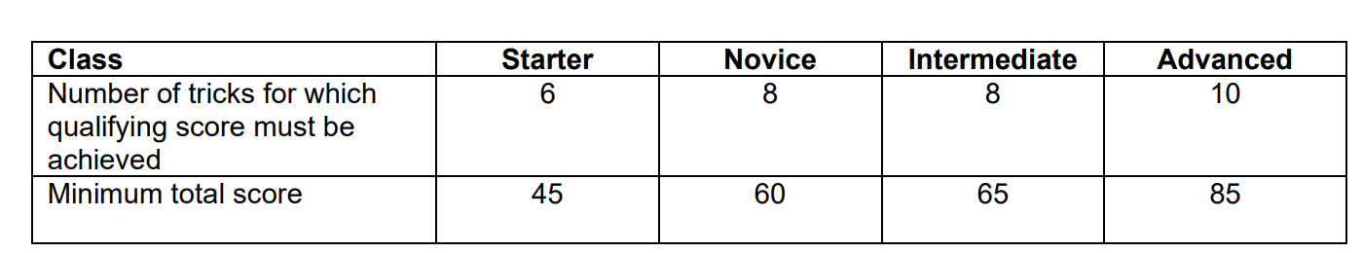
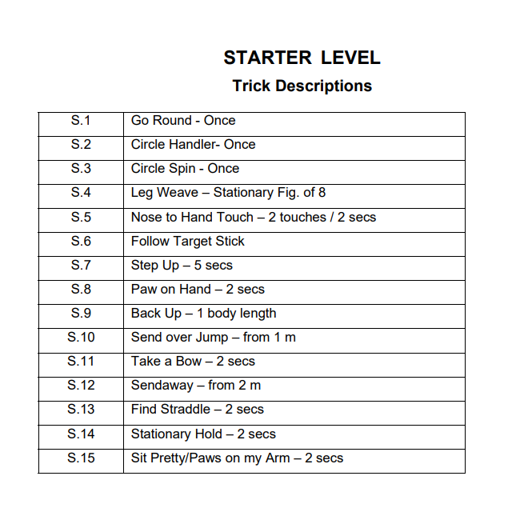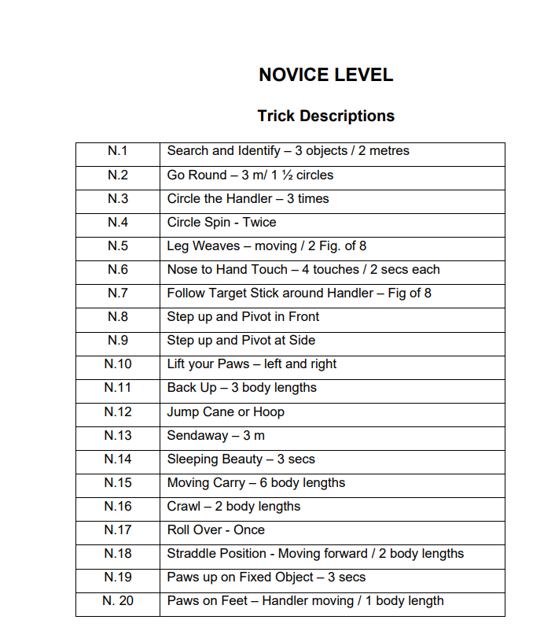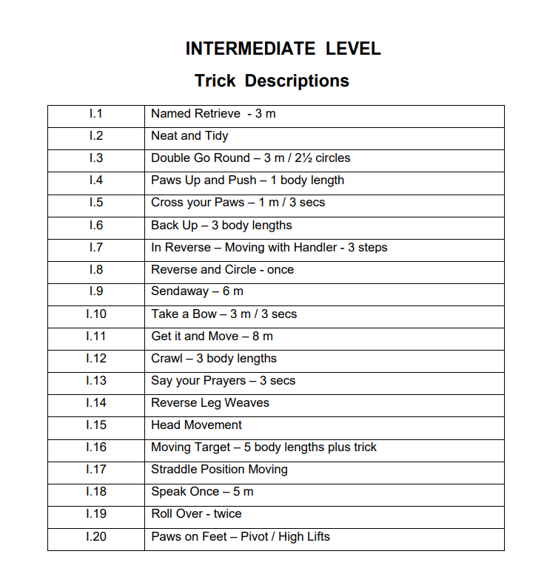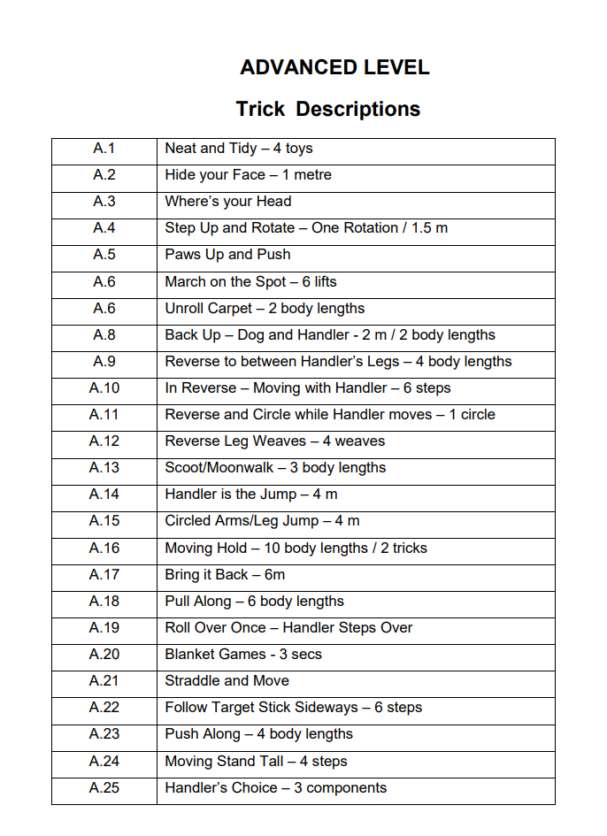
BREED PROFILES KNOW WHATS UNDER THE HOOD…..
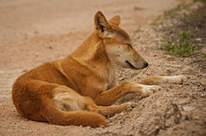
The breed of dog we select will likely carry traits passed down the lines, its called genetics, don’t be surprised if your herding breed dog takes to chasing bikes and cars because it doesn’t have another appropriate outlet for the drive to chase, and your cross bred dog could have traits from all breeds involved. So starting off with a rare specimen in the domestic sense, but we have a couple coming to club for socialisation Mr Podge and Miss Cassy from Bushland Dingo Haven, Earlston. check them out online.
DINGO FAST FACTS:
- Dingoes are not dogs. They are anatomically and behaviourally different﻿, and are classed as a unique species called Canis dingo.
- Dingoes do not bark like a dog but howl, chortle, yelp, whine, growl, chatter, snort, cough and purr.
- Dingoes have a broad diet including fresh meat, fish, eggs and carrion.
- Dingoes have a strict social hierarchy and regularly mate for life.
- Female dingoes have one annual breeding cycle, March to June.
- As a natural predator, dingoes lack body odour.
- Dingoes have no natural health issues and are immune to paralysis ticks.
- Dingoes are far more flexible in limb and hip movement than dogs. They can rotate their wrists and subluxate their hips. These adaptions aid hunting and moving through burrows.
- A dingo’s skull is the broadest part of its anatomy. This assures the dingo that its body will follow its head through any obstacle, no matter how tight the squeeze!
- Dingoes have much larger canine teeth than dogs.
- Males participate in weaning and teaching of young.
- Dingoes can run 60km/hour, travel 40km a day, jump two metres high and successfully climb trees.
- Dingoes are driven by nature’s survival instincts: hunting, procreation, protection of territory and family.
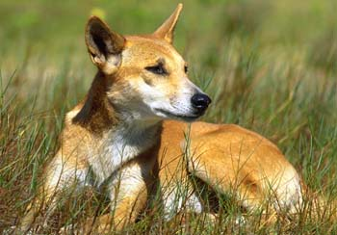
Eye-catching, curious and sometimes dangerous, the dingo can be observed across almost all states and territories in Australia ( excludes Tasmania ) where they play an important role in the natural environment.
The dingo as an apex predator is believed to play a role in keeping natural systems in balance. In addition, dingoes also prey on some feral animals, and in this way can aid the survival of native species.

What do they look like?
The dingo can stand more than 60cm high and weigh between 13–23kg, depending on its geographic location. Dingoes are naturally lean like a greyhound, with large ears permanently pricked and tails often marked with a white tip.
They can be sandy-yellow in colour, some dingoes may also be black and tan white or even brindle
( quite rare according to Gill at Bushland Dingo Haven ).
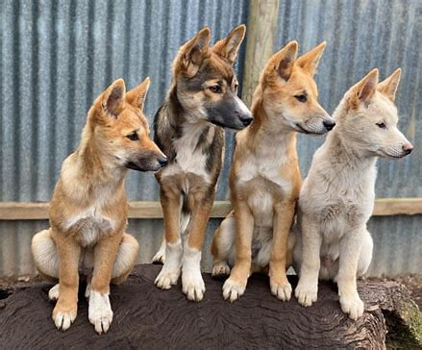
The variable condition of individual dingoes is consistent with populations of other wildlife species and is not an indication of the overall health of the population.
Reproduction
In general, the only dingoes in a pack that successfully breed are the alpha pair, and the other pack members help with raising the pups. Subordinates are actively prevented from breeding by the alpha pair and some subordinate females have a false pregnancy. Low-ranking or solitary dingoes can successfully breed if the pack structure breaks up. They can also successfully cross with the domestic dog to form a cross bred or hybrid ^{such as the Australian heeler.}
Domestication
Dingoes are very intelligent animals, but they should be adopted before 6 weeks old. Otherwise, they will be virtually impossible to domesticate if coming from the wild.
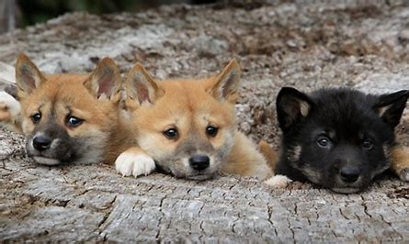

Can You Keep a Dingo as a Pet?
Always check with your local government regarding rules for keeping pet dingoes in your area.
It is illegal in Australia to remove a dingo from the wild and attempt to keep it as a pet.

Australian States where people can keep pet dingoes without any permit is NSW and WA

where permit is required VIC and NT

Australian States where it is illegal to keep a pet dingo. QLD TAS & SA

Be prepared to do your research, you will have to have over 2m fences secure locking gates as those flexible wrists mean they can open handles and the hunt drive is near impossible to change so be ready to muzzle and secure these stunning creatures they must remain on lead at all times when out of their yard, and don’t have small pets or livestock around.

Dingoes are very active and require high levels of exercise and stimulation. Dingoes with excess energy are likely to develop behavioural problems in captivity.
Dingoes can make loving and loyal companions if cared for in the right way. However, it is common for people to underestimate what it takes to properly care for a pet dingo. It is more time consuming, expensive and harder than caring for a dog. Because of this, many owners end up surrendering their dingoes. They can be difficult to re-home and are then put down.

Dingoes are naturally quite shy. They will form a strong bond with their master and be reluctant to spend time with strangers. This makes them seem unfriendly and can be difficult in social situations.
They do not like to be alone for too long so require regular interaction, attention and stimulation. Without this, they can become stressed and behave badly. Because they are prone to boredom and their high prey drive, dingoes are likely to escape and cause damage.
They don’t adapt to new environments well. If you move house regularly, a dingo is not for you. They also cannot be placed in boarding kennels so it can be an issue if you go away on holidays regularly.

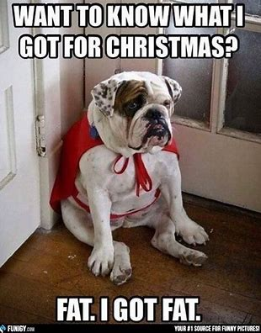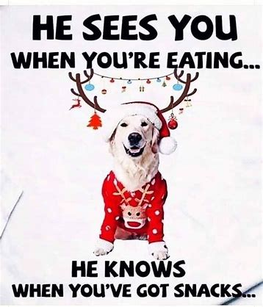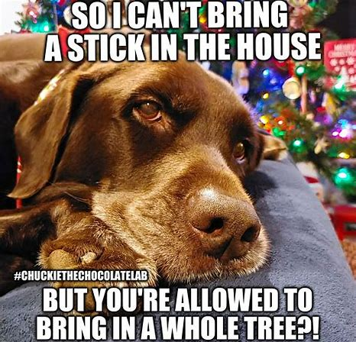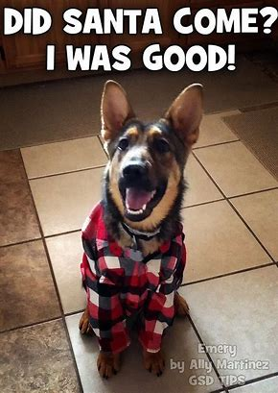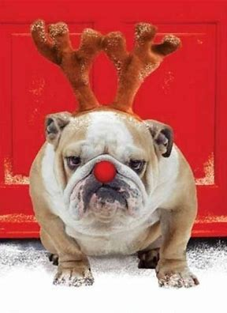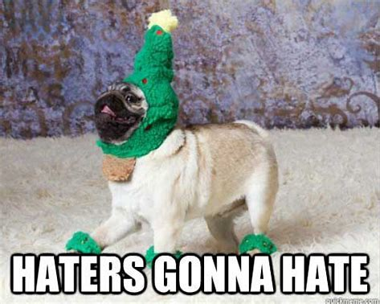
Pets are not just gifts they are a life long commitment so step off on the right foot with this new puppy info courtesy of the bow wow meow insurance puppy pack booklet snippet
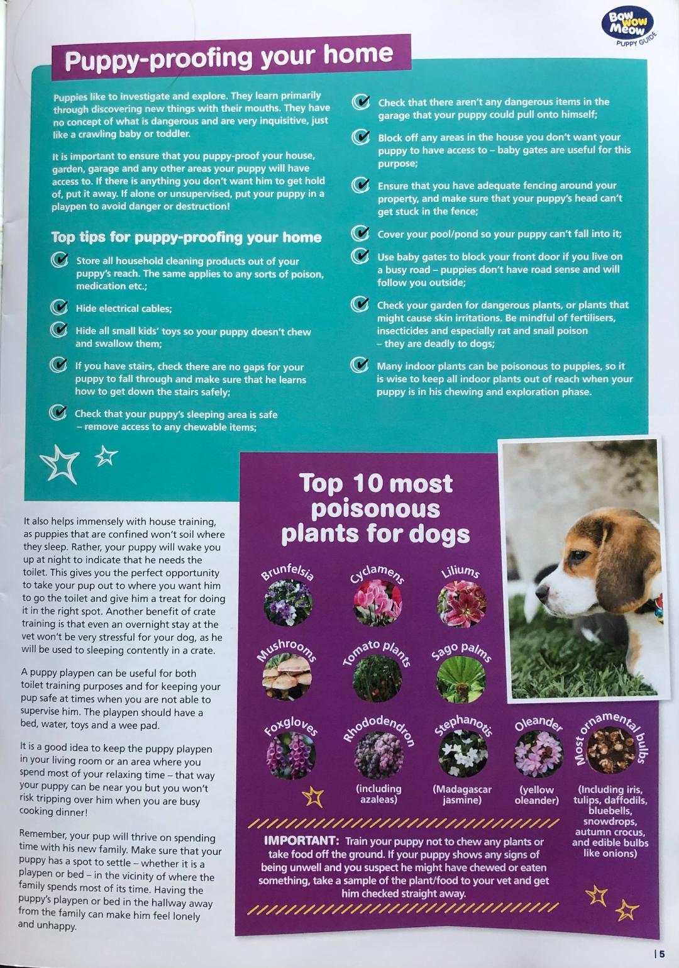
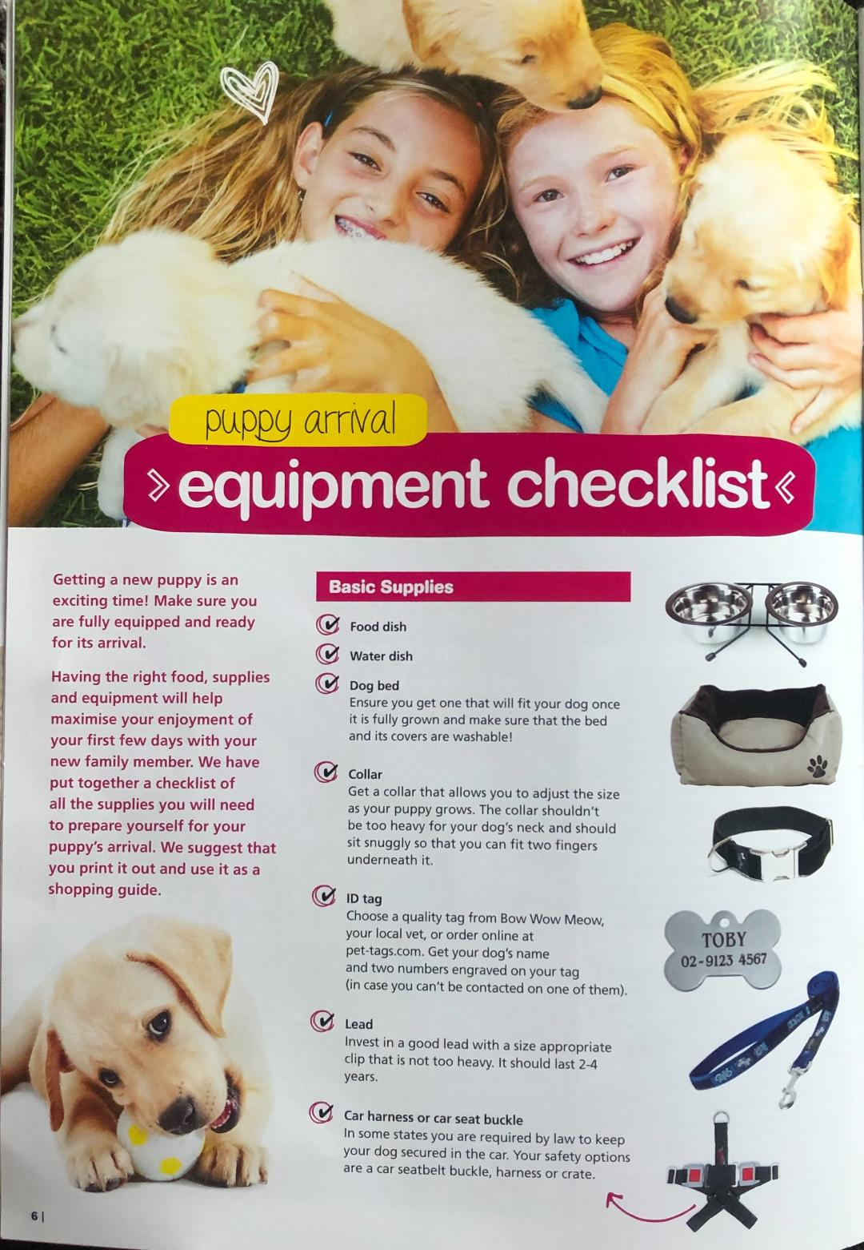
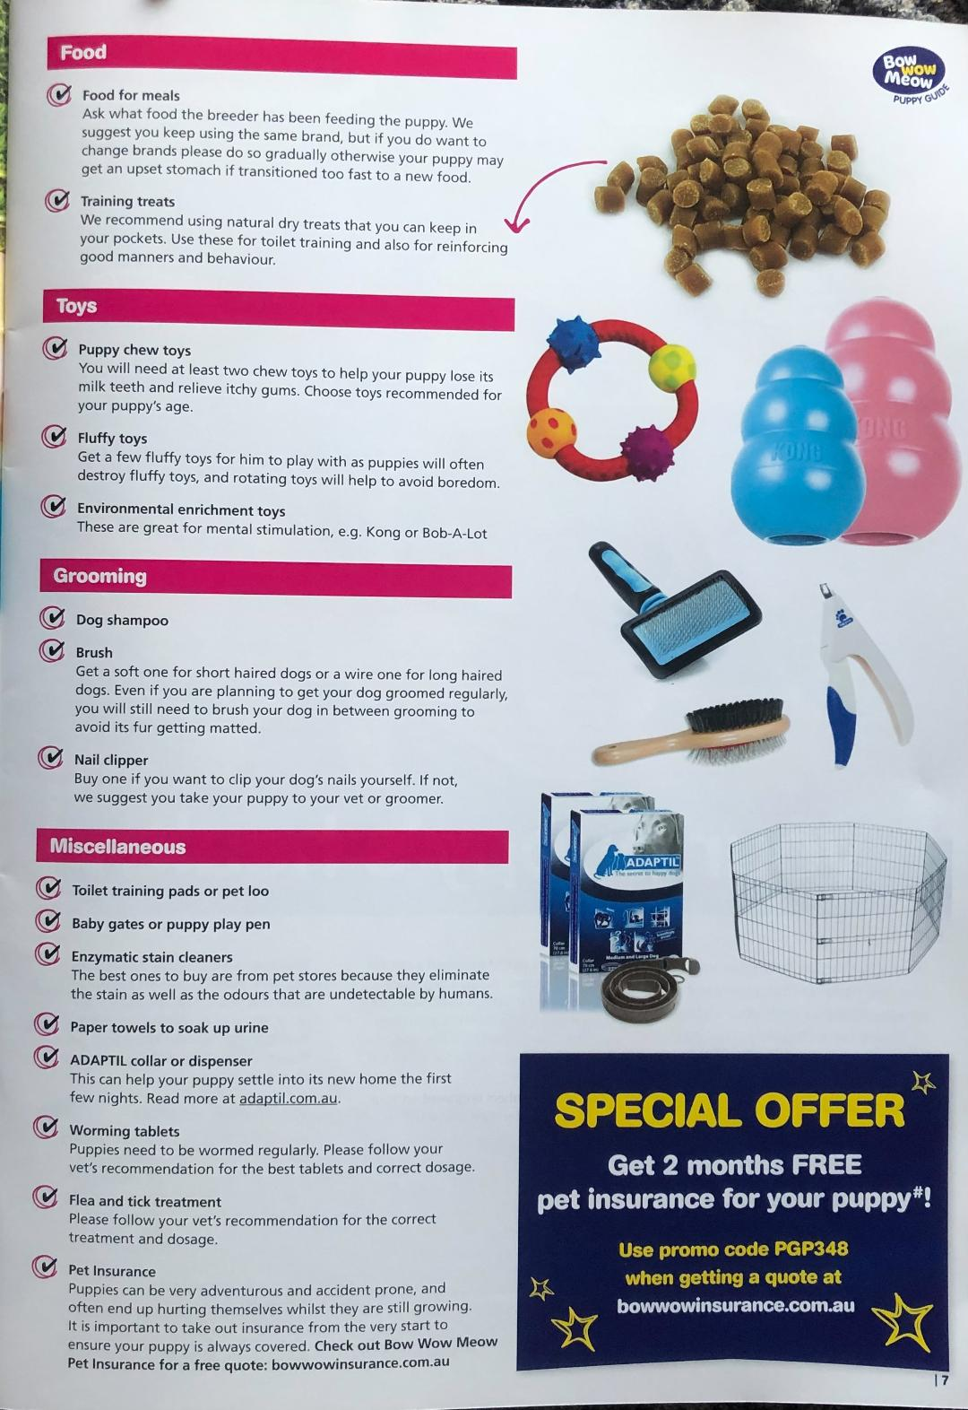

SHEPPARTON & DISTRICT
OBEDIENCE DOG CLUB INC.
ESTABLISHED 1974
PO Box 6230, SHEPPARTON VIC 3632
Email: sheppartonobedience@gmail.com
Website: www.sheppartonobedience.net
CHAS JOHNSON RESERVE
Cnr Balaclava Road and Packham Street, SHEPPARTON
BEGINNER CLASS Starts 9.00 am: 1st Sunday of each month February to November
Bring current vaccination certificate, toy/food for positive reinforcement.

Basic Obedience to high competition standard taught, plus Agility/Jumping, Rally-O, Tracking, Flyball

