January/February 2023
THE GROWLER

Newsletter of the
Established 1974

Note: Articles appearing in this Newsletter are considered to be of interest to our readers and do not necessarily express the opinions of the Committee of Editor of the S&DODC Inc. Who accept no responsibility for the accuracy of claims made by the advertisers in this Newsletter.
SHEPPARTON & DISTRICT OBEDIENCE DOG CLUB Inc.
Inc. No. A0017293M
PO Box 6230, SHEPPARTON VIC 3632

LIFE MEMBERS
Derick DEANE | Vern DEARICOTT | Paddy DEANE | Anna HATTON | Cath GRIFFITHS
Barbara STADING | Sue POLKINGHORNE | Val BIRCHELL | Dianne PELL | David BIRCHELL
Merle HOSIE | Malcolm MCLEOD | Marie MCLELLEN | Olive BARKAUKAS | Marg DELAI
Paul GEESON | Fred MURLEY | Kath MURLEY | Les BESWICK | Elva BESWICK
Julie RAFFERTY | Lola IBRHAIM | Chris THOMSON | Sharon ALLEN | Sharon VAN BUUREN
Darryl WALKER | Leigh WILLIAMS | Helen VERNON | Paul O’BRIEN

OFFICE BEARERS AND COMMITTEE 2021/2022
President: Leigh Williams 0419 315 991 (no private numbers, no calls after 8pm please)
Vice President: Helen Vernon
Secretary: Barb Lloyd
Assistant Secretary: Julie Rafferty
Treasurer: Vacant (Leigh Williams Acting Treasurer)
Committee: Marg Delai, Mellissa Moore, Helen Vernon, Tracey Simmons, David Sanford, Paula Laidlaw
Trial Manager: Robyn Masterson Trial Secretary: Julie Rafferty
Editor: Alicia Jones Property Steward: TBA

Class Times
Beginners/Newcomers and Novice and above Classes: 9.00am to 9.45am
Intermediate and CCD Classes: 10.00am to 10.45am
Every Sunday – Beginner Class: 9.00am – 9.45am
1st Sunday: 09.00 am Obedience for Beginners and Novice, 10.00 am Intermediate and CCD
2nd Sunday 08.00 am Tricks and Scent work
09.00 am Obedience for Beginners and Novice, 10.00 am Intermediate and CCD
11.00 am Committee meeting
3rd Sunday 09.00 am Obedience for Beginners and Novice, 10.00 am Intermediate and CCD
4th Sunday 08.00 am Tricks and Scent work
09.00 am Obedience for Beginners and Novice, 10.00 am Intermediate and CCD

Every second month on the last Sunday; Graduation testing only 9.00am
Special Note : "No Training Easter Sunday" 9th April
Heat Rule
When the weather forecast for Sunday by the BOM for Shepparton is 35 deg, or above as declared on the prior Saturday night, there will be no training on Sunday morning even if the weather forecast is revised.

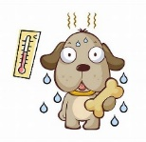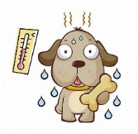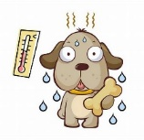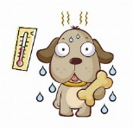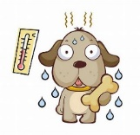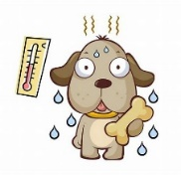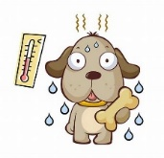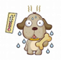
MEMBERSHIP
With effect from 2020, the membership year runs from 1st January to 31st December each year.

Membership Fees are due for Renewal until the end of February 2023.

If you fail to renew before the end of February 2023, you will be required to pay the joining fee again.

Current Membership fees:
Singles $30.00
Family $60.00
Junior $20.00
The joining fee is $10 + $8.65 insurance Class fees have not changed and remain at $3.00

REMEMBER ALL CURRENT MEMBERS RENEWAL DUE BEFORE FEB 28TH OR JOINING FEE WILL BE CHARGED
Graduations

Held the last Sunday-March, May, July, September & October
Eligible—Intermediate class and above
Starting 9.00 am Beginner class is held as normal at 9 am

It is a fun time and you get one on one advice from the judges to help you understand the progress you are making, also it is practice if you intend to enter Open Trials. The obedience exercises that are practiced in your current class are the exercises upon which you and your dog will be judged individually. The Sit and Down stay are group exercises. There are Certificates & ribbons for place getters & a passing score means you move up to the next class.

Your 3 highest scores earned at three Graduations in the calendar year count towards determining the End of Year Trophies:-
Lady Handler, Male Handler and Junior Handler.

Exercises -
Intermediate—All exercises are on lead. Heel pattern with sits, stands & drops; sit for examination; recall; sit and down stay as a group.

CCD (Community Companion Dog)- All exercises are on lead except the sit & down stay. Heel pattern with Figure of 8, Sits, Stands & Drops; Stand for examination; Recall, 1 min Sit and 2 min Down stay as a group.

Novice — All exercises are Off lead - Heel pattern with Figure of 8, sits, stands & drops, Stand for examination; Recall; Dumbbell retrieve or Change of position; 1 min Sit and 3 min Down stays.

Open — All excises are Off lead— Heel pattern as above; Stand for
examination; Drop on recall; Retrieve dumbbell on flat; Retrieve dumbbell over solid jump or Directed retrieve (gloves); Broad jump or distance control; 3 min Down stay out of sight.

UD (Utility Dog) – upon request

Intermediate & CCD scores— A qualifying score 85, out of 100.
Novice & Open Scores— A qualifying score 170, out of 200.
Handlers pass Intermediate, CCD and Novice once, not necessarily in the same year. Open and above classes can be repeated at any graduation.
Presidents Page – February 2023
Welcome to the new year all our returning members and a big welcome to our new members. It is great to see everyone spending time with their dogs learning new skills and working to hone the ones they already have. It is very important to remember to be patient and if you have a problem take a step back and break it down, what is wrong, how has it happened and what can I do differently to change the outcome, you will not be able to train your dog on a Sunday morning in class, it will take practice with lots of short fun training sessions at home.
With the weather continuing to be warm it is important to remember to look after our dogs, plenty of shade and water available, if possible, on very hot days inside with air conditioning to prevent overheating. No walks or exercise in the heat of the day, very early morning on late in the evening is best, remember concrete and sealed surfaces can retain heat and can easily burn paws, if the ground is too hot for you to walk with bare feet it is too hot for your dog. The last one to remember is do not leave dogs in cars, even on a relatively mild day a car in the sun can heat up very quickly to dangerous temperatures.
Some of our very dedicated members continued to train over the summer break with tricks and scent work training happening every second week, a big thank you to Julie and Helen for taking the lead on these classes. Tricks and scent work classes will now move back to the second and fourth Sundays of the month, and back to the early start time of 8 am, I know one or two members that will not be happy with this, they don’t like the early start!
Our Tricks trial is progressing with entries open with the big day set for 1 April 23, I encourage all members to think about practicing and putting an entry in (you will need to be a Dogs Vic Member to enter), if you are not wanting to enter we will need lots of helpers so please put the date in your calendar now, many hands make light work, and you will be able to see how an official trial operates in your own back yard.
A reminder that for returning members annual membership fees are due by the end of February, you will also need to provide an update to your dog’s vaccinations.
It is great to see everyone back and we are all looking forward to another busy year and some success with our training goals, no matter how big or small, wishing everyone loose leads and attentive dogs for the year ahead.
Kind Regards,
Leigh Williams
President

Here when you need us
7 days per week
2 Wanganui Road, Shepparton
03 5821 3188
7966 Goulburn Valley Hwy, Kialla
03 5823 1202
Your pet is a very important member of your family, which is why we set the highest of standards for our hospital and clinics. We are passionate about doing the very best for your pet, and believe in working together, in alignment with our shared values. We are dedicated to delivering the best veterinary care and expertise at our 2 great locations.

MEET OUR VOLUNTEERS

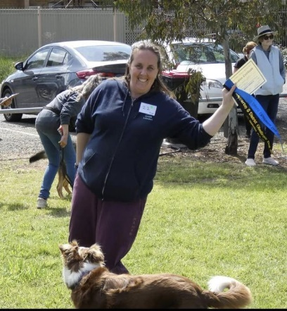
ALICIA
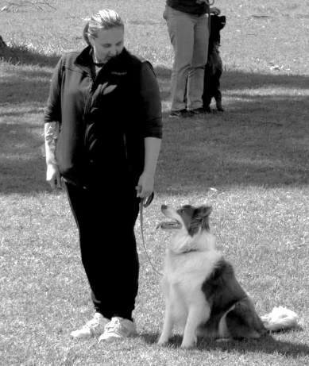
Growing up with dogs all her Life its no surprise she ended up working with them also, As a Vetnurse she went on to study Dog training only to learn you cant learn it all from a book, she loves coming to club to watch and learn to practice and to socialise but also to support those who may be a little socially awkward or worried about their dogs being naughty as she herself has a worry wart bordercollie named Ziggy that you will no doubt see around club in all his howling and growling glory ( trust me he has improved imensly since starting at club.)
You will often see Alicia floating around helping in class or filling in as instructor when needed. But mostly on the oposite side of the camera phone snapping away around the field. So these are rare pics of left her and ziggy and right highest graduation score with her koolie Emmy.

TEACH YOUR DOG TO SPEAK ON CUE
Then to be quiet.
- FIND SOMETHING THAT YOUR DOG NATURALY BARKS AT ( COULD BE A TOY, A DOOR BELL OR EVEN YOU GETTING EXCITED )
- Capture the behaviour with a clicker or your mark word “ yes “ and treat.
- Repeat until your dog is starting to see the pattern.
- Add your cue “ speak” ( or any word you choose like “ tell me “ or “woof” ect ) present the stimulus as in step 1 but with the cue word added FIRST. “Speak” – present toy – dog barks – mark – reward
- Now to reduce the stimulus cue “Speak” and wait to see if they bark to mark and reward. If not just repeat the previous step then perhaps slow the presentation of the toy until your dog is seeing the new pattern.
- Once its all on cue move to new locations and try it out remember trick training should always be positive and fun.
- NO FLIP IT….. say quiet or enough - wait for the barking to stop even for a second and mark and reward the good quiet 😊

Congratulations
to 2022 Award Winners

Top male handler
Anthony Lockett with Alan

Top Lady Handler
Julie Rafferty with Davey

Top Agility Dog
Davey with Julie Rafferty

Jip Perpetual Award (Rally)
Julie Rafferty with Jasper

Top Tracking Award
Belinda Farley with Vinnie and Archie

Mia Perpetual Award (Agility)
Julie Rafferty with Davey

Encouragement awards
Emma Francis with Phoebe
Bill Hipwell with Scout
Linda Pettinella with Ben

EVERYONES A WINNER FOR GETTING OUT WITH YOUR FURRY FAMILY MEMBER

Upcoming Regional Tricks, Obedience and Rally Trials

Ballarat Obedience Dog Club
Tricks Trial
Saturday 4th March 2023

Kyeamba Kennel & Dog Training Club, Wagga
Tricks Trial
Saturday 11 March 2023

Albury & Border Kennel Club
Double Obedience & Rally Weekend
Saturday & Sunday 25th & 26th March 2023
Entries close 3rd March 2023, entry through ShowManager

Shepparton & District Obedience Dog Club Inc.
Inaugural Triple Tricks Trial
Saturday 1st April 2023
Entries close 18th March 2023, entry through K9 Entries

Bendigo Obedience Dog Club
Tricks Trial
Saturday 6th May 2023

Wangaratta Kennel & Obedience Dog Club Inc
Triple Rally and Triple Obedience Trials
Saturday & Sunday 13th & 14th May 2023
Upcoming Regional Tricks, Obedience and Rally Trials
Ballarat Obedience Dog Club
Tricks Trial
Saturday 4
th
March 2023
Kyeamba Kennel & Dog Training Club, Wagga
Tricks Trial
Saturday 11 March 2023
Albury & Border Kennel Club
Double Obedience & Rally Weekend
Saturday & Sunday 25
th
& 26
th
March 2023
Entries close 3
rd
March 2023, entry through ShowManager
Shepparton & District Obedience Dog Club Inc.
Inaugural Triple Tricks Trial
Saturday 1
st
April 2023
Entries close 18
th
March 2023, entry through K9 Entries
Bendigo Obedience Dog Club
Tricks Trial
Saturday 6
th
May 2023
Wangara.a Kennel & Obedience Dog Club Inc
Triple Rally and Triple Obedience Trials
Saturday & Sunday 13
th
& 14
th
May 2023
BREED PROFILES KNOW WHATS UNDER THE HOOD…..

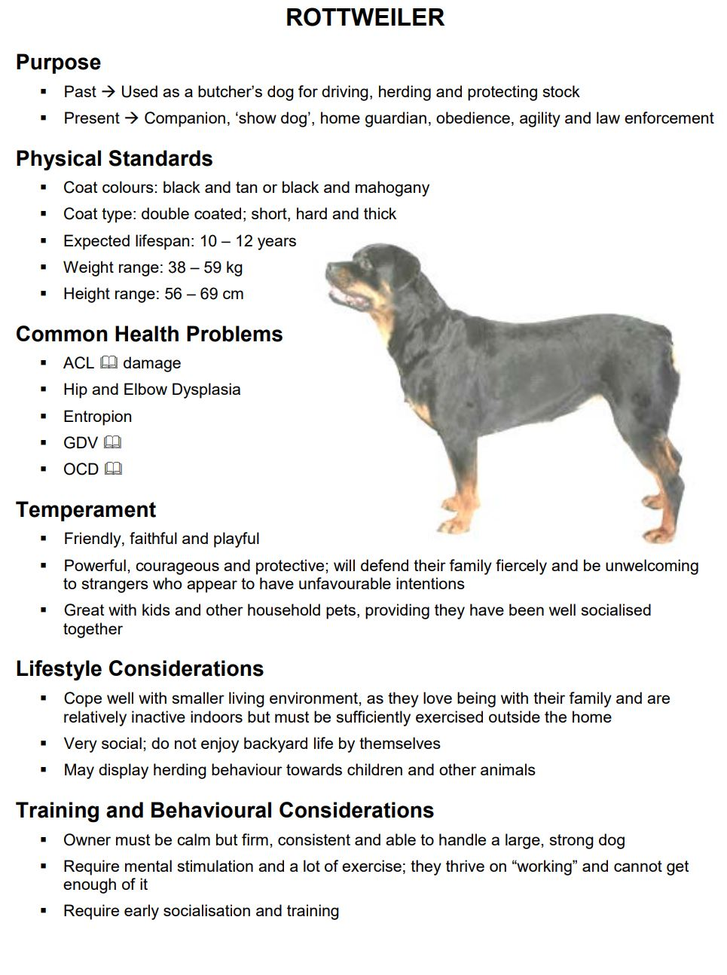
Info courtesy N.D.T.F Training booklet - breed profiles
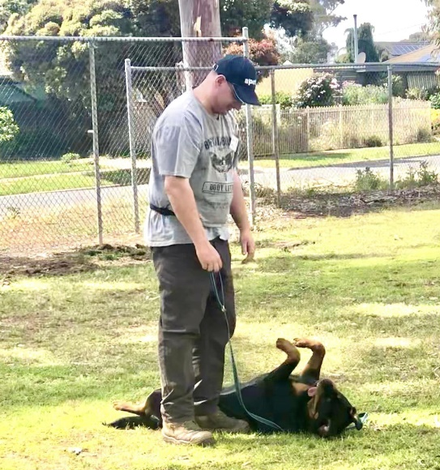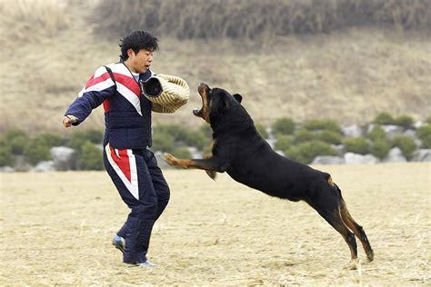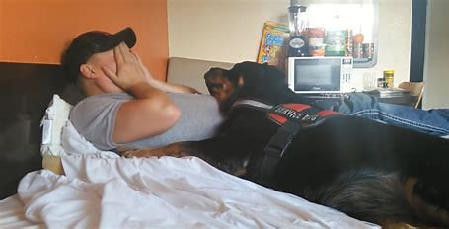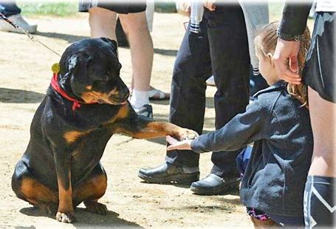
Service dog returned soldier PTSI

OH&S REMINDER
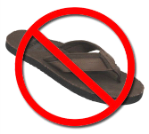
Please wear appropriate footwear when training your dog in class
No thongs or open toe shoes
If your dog steps on a thong, you can fall and may need medical attention, plus the noise from thongs can distract or upset your own dog or other dogs. Long coats and flappy skirts/dresses can also distract your dog from training.
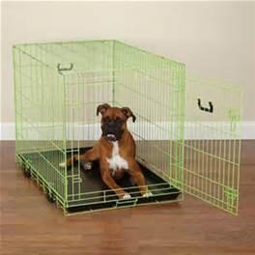
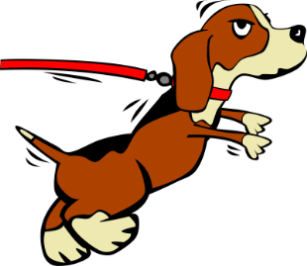
WARNING - Please do not touch or walk close to unattended dogs that are tied to a fence or post etc. This also includes dogs that are in crates.
When dogs are tethered or contained they see the area around them as “Their” space and will protect it. Be aware and walk about 2 metres away from them.

Dr Anna Richards BVSC.
and Associates

103 McLennan St
P O Box 231,
MOOROOPNA VIC 3629
Phone 03 5825 3911
Fax: 03 5825 3229
www.causewayvet.com.au

Anna & Sue welcomes you to the Causeway Veterinary Clinic and offer a full range of veterinary services for small animals, they are as dedicated to looking after your animal, as they are to their own. This family owned business has operated for many years providing the ultimate in pet care for your beloved family members.

SHEPPARTON & DISTRICT
OBEDIENCE DOG CLUB INC.
ESTABLISHED 1974
PO Box 6230, SHEPPARTON VIC 3632
Email: sheppartonobedience@gmail.com
Website: www.sheppartonobedience.net
CHAS JOHNSON RESERVE
Cnr Balaclava Road and Packham Street, SHEPPARTON
BEGINNER CLASS Starts 9.00 am: 1st Sunday of each month February to November
Bring current vaccination certificate, toy/food for positive reinforcement.

Basic Obedience to high competition standard taught, plus Agility/Jumping, Rally-O, Tracking

