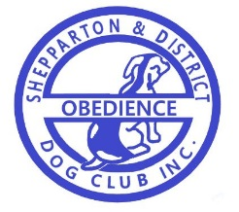

SHEPPARTON & DISTRICT OBEDIENCE DOG CLUB INC.

NOTIFICATION OF TITLES

Email the following details to secretary at sheppartonobedience@gmail.com

Please print clearly
Members name: _______________________________ Phone no.__________________
Dog’s pet name: ________________________________________________
Title/s gained in: ________________year (please circle title below)

CCD CD CDX UD UDX O CH GR O CH (Obedience)
RN RA RE RAE RM RO CH (Rally)
TK.S TK.N TK.I TK.A (Tricks)
SWN SWA SWE SWM (Scent works)
AD ADX ADM ADO JD JDX JDM JDO Ag Ch (Agility & Jumping)
TD TDX TCH TSD TSDX TS CH TS GRAND CH (Tracking)

Other, please state discipline and title (as per qualifying certificate)
…………………………………………………………………………………………………………………………………………….

