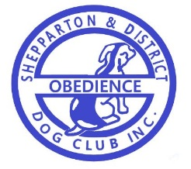

SHEPPARTON & DISTRICT OBEDIENCE DOG CLUB INC.

NOTIFICATION OF TITLES

With so many members receiving titles, it is now necessary for an official form to be returned to our Secretary.

Email the following details to secretary at sheppartonobedience@gmail.com (subject line: Club Titles Notification)

Please print clearly
Members name: _______________________________ Phone no.__________________
Dog’s pet name: ________________________________________________
Title/s gained in: ________________year (please circle)

RN RA RE RAE RM RO CH (Rally)
CCD CD CDX UD UDX O CH GR O CH (Obedience)
ET (Endurance)
AD ADX ADM ADO JD JDX JDM JDO Ag Ch (Agility & Jumping)
GD GDX GDM SD SDX SDM SPD SPDX SPM (Games)
TD TDX TCH TSD TSDX TS CH TS GRAND CH (Tracking)
NRA ORA (Retrieving)
DWD (Dances with Dogs)
Other: (Herding, Flyball, etc) (use recognised initials):

